FROM THE DESK OF THE CEO (22/17)
(Follow me on Twitter justchad_cga)
Justin Chadwick 16 June 2017
“Russia is a riddle wrapped in a mystery inside an enigma” Winston Churchill
FIRST BREAK BULK VESSEL for 2017 ARRIVES IN St PETERSBURG
Mikhail Fateev reports:
On the 7th of June a briefing for Russian journalists was organized by CGA/FPEF in collaboration with Russia-RSA Business Council, Chamber of Commerce of Russian Federation and RSA Embassy in Moscow in connection with arrival of M/V Regal Bay, the first vessel load with SA fruits in season of 2017. The briefing was held in Moscow at premises of the Chamber of Commerce and Industry. Mass media pool was represented by journalists from the pool of RSA Embassy and Chamber of Commerce, altogether 10. The briefing was chaired by Executive Secretary of Russia/RSA Business Council. Present were diplomats from RSA Embassy, representatives of Euroasian Economic Commission, Plant Quarantine Research Institute, Nutrition Institute, leading importers. On big screen photo serials of fruits discharge in the port of St. Petersburg were demonstrated. Samples of fresh citrus from SA (lemons, mandarins, grapefruits) were presented by one of the leading importers. Alongside with information on history of trade relations in fruit sector, current volumes of trade, questions were asked and replies given with regard to “stickers” problem. Although Russian Customs authority of Sanitary Service (Rospotrebnadzor) acknowledge acceptance of marking attached to pallets (not on each carton), on the grass root level inspectors may obstruct this variant of marking. Therefore information on such cases is expected at Russia-RSA Business Council and RSA Embassy in Moscow. An interesting report was made by Natalia Tobina, anti-aging specialist. She was reporting to journalists on medical value of grapefruits for age control as anti-oxidants. Reference to the Chamber’s press release is as following
http://tpprf.ru/ru/news/pervye-chetyre-tysyachi-tonn-yuzhnoafrikanskikh-fruktov-postavleny-v-rossiyu-i194439/
LEMONS: VOLUMES START TO GROW
With lemons taking on “super fruit” status around the globe increased supply is measuring up to the increased demand. Figures extracted by John Edmonds (CGA Information Manager) up to week 22 show that lemon exports out of the southern hemisphere are significantly higher (year to date) than the previous year.
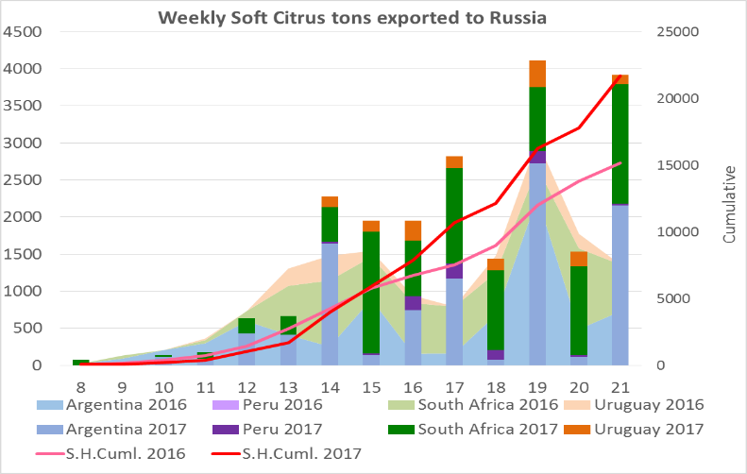
The projected final export remains at March’s estimate of 17.5 million cartons. Current shipping is up to 7.7 million cartons; 13% up on the 6.8 million cartons last year. SHAFFE data shows Russia having imported 20 000 tons more lemons from South Africa and Argentina by the end of week 22.

PACKED AND SHIPPED
To End Week 23  Million 15 Kg Cartons | Packed | Packed | Packed | Shipped | Shipped | Original Estimate | Latest  Prediction | Final Packed
SOURCE: PPECB/Agrihub | 2015 | 2016 | 2017 | 2016 | 2017 | 2017 | 2017 | 2016
Grapefruit | 12.6 m | 9.1 m | 11 m | 6.3 m | 7.4 m | 15.6 m | 15.3 m | 13.2 m
Soft Citrus | 5.3 m | 6.6 m | 6.2 m | 5.2 m | 4.7 m | 13.2 m | 13.2 m | 12.2 m
Lemons | 8 m | 8.6 m | 10.7 m | 7.4 m | 8.8 m | 17.5 m | 17.5 m | 15 m
Navels | 8.4 m | 11.4 m | 8.4 m | 7.4 m | 5.1 m | 26.3 m | 22.6 m | 26.2 m
Valencia | 1.4 m | 1 m | 2.1 m | 0.4 m | 0.2 m | 50.1 m | 49.4 m | 41.8 m
Total | 35.7 m | 36.7 m | 38.4 m | 26.8 m | 26.2 m | 122.7 m | 118 m | 108.4 m
THE CGA GROUP OF COMPANIES (CRI, RIVER BIOSCIENCE, XSIT, CGA CULTIVAR COMPANY, CGA GROWER DEVELOPMENT COMPANY & CITRUS ACADEMY) ARE FUNDED BY SOUTHERN AFRICAN CITRUS GROWERS

