Article from FreshPlaza – 26th May 2017(with their permission)

"It's amazing how it has turned around."

South African grapefruit exporters not rushing things during peak season
“The European market is emptier than we expected, with many South African producers sending to Asia/southeast Asia or the Far East. Apart from remnants from Spain, Israel and the USA, we’re about the only ones with grapefruit at the moment,” says Nico Kotze, head: marketing and sales at Bonaire Fruit.

“After 2014, which was a poor year for grapefruit, it’s amazing to see how it has turned around. Grapefruit and grapefruit juice consumption is a bit of a health trend in the world now. France is traditionally a strong country for our grapefruit, along with other Mediterranean and Baltic countries. All markets seem to be on consistent price and volume levels which is positive for the industry as a whole.”

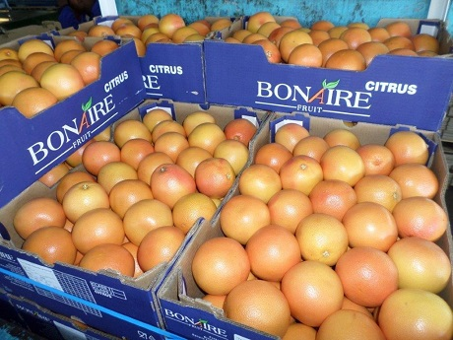

Bonaire markets grapefruit mainly grown on the Maswiri Farms in the Tshipise area, on the border with Zimbabwe, which opens the grapefruit season in South Africa (like it does other varieties too: the second consignment of Bonaire Valencias has already left for southeast Asia, China and Europe). Their grapefruit harvest and packing will be concluded next week with Marsh, destined mainly for Asia, but for which the demand in Europe is also increasing.

Grapefruit from the Eastern Cape isn’t due to start coming in until around week 31.

South Africa is currently in its grapefruit supply peak, primarily due to production in Limpopo Province, but these days some of the fruits are left on trees into July if markets are soft (“the least expensive storage space is on the tree” says Jan-Louis Pretorius, chair of the CGA’s grapefruit variety focus group) instead of rushing to harvest and shipping as soon as possible. In 2014 much larger grapefruit volumes from South Africa would’ve reached markets by now but more attention is now paid to reading the markets; this year by the end of week 19, 2.6 million cartons (14kg) had been shipped.

Marthia Botha of Orex Exports, a producer-exporter from the Orange River area, agrees that the grapefruit market in very strong. The company markets its grapefruits in the European market as well as to Canada. “It looks promising, the volumes are up after the very high temperatures we had during flowering in 2015, but we can see that temperatures are climbing higher every year. We try to mitigate the rise in temperature through protective netting but due to the high costs, we can only do it bit by bit,” she says. The company has been growing grapefruit in the Northern Cape for 18 years.

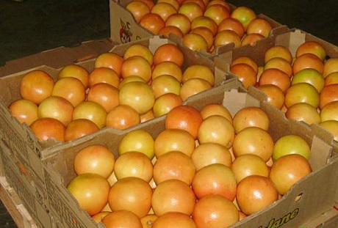
Picture courtesy of Malelane Citrus

Most of South Africa’s grapefruit production comes from Limpopo Province, where the grapefruit season will run until the first week of July. Christo Naudé, marketing and logistics manager at Malelane Citrus Co-op agrees that prices are good. “We’re very grateful, we’ve come out of a period in which the grapefruit industry really struggled, but this is the third year that it’s looking good.”

He stresses the importance of spreading product across many markets. “Before producers would rush to markets that were doing well and we cut our own throats in the process, but since then, plans have been put in place to regulate volumes and to evenly distribute volumes across the markets in order to keep the markets healthy. Everything depends on healthy markets. The crux of the matter is: don’t rush things.”

Malelane Citrus packs around a million cartons of grapefruit (Star Ruby accounts for 70%, Marsh 20% and Rosé 10%) from seven producers in the Onderberg area in its three packhouses. Its shaddock (pomelos) have finished now. There are plans to upgrade the packhouses next year to improve packout-out percentage.

The original country estimate of 15.6 million grapefruit cartons have been lowered to 15.1 million cartons. A fraction of the harvest is marketed locally, for which fruit are picked very early and selectively, before internal quality has reached export quality standards, because the domestic appetite for grapefruit dwindles as autumn approaches (end of March/April). “The grapefruit that the South African consumer eats and the grapefruit that is exported, are two totally different grapefruits, even if the same variety,” says Christo Naudé of Malelane Citrus. “Grapefruit for export isn’t bitter at all.”

For more information:
Nico Kotze
Bonaire Fruit
Tel: +27 21 876 2250
Email: nico@bonaire.co.za
http://www.bonaire.co.za/

Christo Naudé
Malelane Citrus
Tel: +27 13 790 0391
Email: Christo@msk.co.za
http://msk.co.za/

Marthia Botha
Orex Exports
Tel: +27 54 431 6100
Email: mspan@isat.co.za
http://www.orexexport.com/

Publication date: 5/26/2017
Author: Carolize Jansen
Copyright: www.freshplaza.com

