Warning against artificially high and unsustainable price levels

Far East "screaming" for navels from South Africa
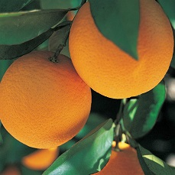
While there is acute interest in South African navels, particularly from the Far East, some exporters warn against pushing prices to artificial levels that cannot be maintained.

In areas unaffected by navel splitting, like Mpumalanga and Limpopo, exporters tell FreshPlaza that their phones have been ringing off the hook for the past couple of weeks, as importers from the Far East look for alternatives to Eastern Cape navels. Exporters from the Western Cape, where navel damage is estimated at around 17 to 20% of the crop, similarly report that the Far East “is screaming for navels”.

Large volumes for the Far Eastern markets are still in transit and only 2% of navels have reached Hong Kong and China and 9% have landed in Southeast Asia thus far. This region drives a growth in navel demand. At this point, it is difficult for exporters to give an accurate picture of the prices for navels in those markets. An exporter sounds a cautionary note in this regard: “There is a danger that with the strong demand from the Far East, which has high quality requirements, a decision can be made to send lower specification navels to take advantage of the situation. What can then happen is that this fruit goes unsold or is eventually sold at such a discount that it pulls down the prices for high specification fruit.”

“The demand for navels is very healthy, prices will certainly be higher than traditionally, but you have to send high quality fruit to the Far East. There is similar strong demand from the EU, Russia and the Middle East,” says Carel van Rooyen, director of Impala Citrus. “However, perhaps prices won’t reach the levels that some anticipate. For us, it’s about getting the right price, not necessarily the highest price.”

Navels from Schoonbee Landgoed, in Mpumalanga, are expected to reach the Chinese market this week, and while the market is generally reacting well, it’s too early to give price indications for navels in that market, says Gert Upton, marketing manager.

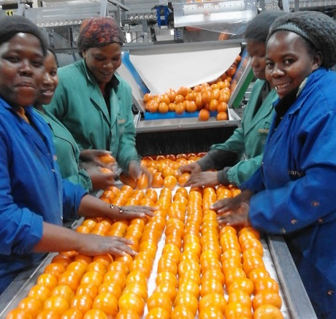

The majority of navels have gone to the Middle East and the EU, with Russia taking a bite from a harvest characterised by a sizeable percentage of large-sized fruit. When there are good volumes of smaller sizes in navels, eyes will turn to the Middle Eastern market again, with the complications that the blockade of Qatar might entail.

Western Cape citrus growers have the additional market of the United States of America open to them. Goede Hoop Sitrus sends around 60% of its navels there, where the market is much stronger than last year, says Pierre Hough, manager: client affairs, with their own product out of the market earlier than usual. Despite lowered navel volumes, the peaks are comparable to previous years, but the expectation is that the season will end earlier than usual, at around week 27.

In Citrusdal, Western Cape, which had good rain last week and snow on the Cederberge, the harvest will now have to resume in earnest before fungal infections, an inevitable addendum to good rain, start taking their toll. Okkie Burger of Quattro Citrus says that creasing of navels can have an influence on the harvest, which means fruit have to come off the trees as soon as possible. Their growers report an average downturn of 20% in their navel volumes due to splitting. They market approximately a quarter of their navels to the USA, with the balance to the UK, the Middle East and Russia but little to the Far East because of that market’s preference for smooth-skinned navels.

Shipped volumes of navels are significantly lower than last year – 3.3m 15kg cartons versus 5.4m cartons at the end of week 22 last year, with a difference of 1.1m 15kg cartons shipped during week 22 itself between this year and last.

For more information:
Carel van Rooyen
Impala Citrus
Tel: +27 21 110 0900
Email: carel@impalacitrus.co.za

Gert Upton
Schoonbee Landgoed
Tel: +27 13 262 4000
Email: marketing@schoonbee.co.za
http://schoonbee.co.za/

Pierre Hough
Goede Hoop Citrus
Tel: +27 22 921 8129
Email: pierre@ghcitrus.com
http://www.ghcitrus.com/

Okkie Burger
Quattro Citrus
Tel: +27 22 100 0108
Email: okkie@quattrocitrus.co.za
http://www.munoz.co.za/

Publication date: 6/12/2017
Author: Carolize Jansen
Copyright: www.freshplaza.com

