Deon Joubert - CGA
South Africa: No cold steri treatment for citrus this season
At last week's Fruit Logistica in Berlin, Deon Joubert took the opportunity to hold a briefing for the citrus industry on the issues of CBS and the False Codling Moth, both of which could have an impact on South African citrus exports to Europe.
The CBS issues are not new to anyone in the business and the South African citrus industry has been working for years to minimise the interceptions of affected fruit into Europe at a huge cost to the industry of around 1 billion Rand. They have been on the whole successful with only four interceptions last season, two of which were in the last week. Admittedly it was dry year, which helped and according to Deon they will have to remain vigilant in the coming season.
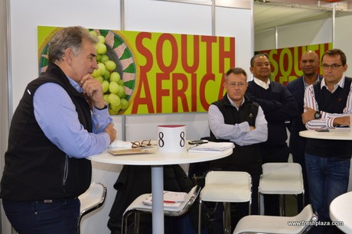
Deon Joubert giving the briefing the citrus growers in Berlin
The False Codling Moth (FCM) issue raised its head last year, when it was proposed that all South African citrus entering Europe would have to under-go cold steri treatment. This is impractical and unnecessary according to the South African Citrus industry, "A lot of today's varieties could not stand up to the treatment and a blanket regulation on citrus is ridiculous, especially when other produce such as capsicums had a lot more incidences of FCM than citrus," said one citrus exporter.
In the briefing Deon explained that there would not be any change this season, no steri treatment whatsoever.
South Africa is confident there are more effective and proactive measures to deal with FCM in future seasons if it becomes a managed pest in the EU.
"We definitely need to act on this in the coming season," said Deon. "We need to get this under control and will implement a range of measures depending on the situation in each area. DAFF will inspect EU fruit with a zero tolerance. We will be meeting to discuss a plan of action."
The CGA was happy with the change of wording back to the June 2016 text which is now used for the pending legislation to read, 'Cold treatment or any effective treatment' instead of only cold treatment.
South Africa has been working for years on reducing the FCM in citrus orchards, with fantastic programs running throughout the country. The FCM moth and its life-cycle is fragile according to Deon. This has been the focus of the CRI research on FCM over the last 20 years.
FCM has been around for years and has not established itself in Europe due to various factors, such as not successfully completing its life-cycle [mating, finding a suitable host and surviving cold temperatures].
The CGA discussed options for cold treatment in certain limited cases, should it be suited to the fruit variety, but not as a blanket measure.
For more information:
Deon Joubert
Special CGA Envoy: Market access & EU matters
Phone: +27 83 675 3785
Email: deonj@cga.co.za
Publication date: 2/16/2017
Author: Nichola Watson
Copyright: www.freshplaza.com

