Fresh Plaza – 19th July 2017

Good Valencia season in the north of South Africa
“The citrus season in the north is much as we hoped, with volumes up after the devastating hail in Hoedspruit,” says Maarten Venter, marketing manager at Zest Fruit. “Quality is good, although fruit reached maturity a bit earlier than usual, so we expect to be finished about two weeks earlier on citrus from the north. Apart from lemons, most markets are stable, with supply and demand well-balanced on world markets.”

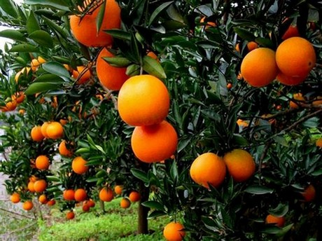

The grapefruit season in the north of the country is almost at an end, with about two weeks still to go in the Onderberg region on Star Ruby. Valencia varieties, including late Valencias, still have three months to go up in the north of the country.

Fanie Meyer, Citrus Growers’ Association representative for the Hoedspruit region, confirms that the season in Hoedspruit is progressing very well. “We’re 90% finished with grapefruit, also almost done with Turkey Valencias, and currently packing Midknights. The pack-out looks good, the volumes look good, with YTD counts peaking at 72 and 64 which are easily marketable counts in all markets.”

Midknights in Hoedspruit are expected to run until end of week 31; it is a widely popular fruit in all markets. Late Valencias in this area will finish in about week 37. By end of September all Valencias originating in Hoedspruit should have been packed.

The Valencia picture in Limpopo Province (responsible for approximately 60% of South Africa’s Valencias) looks brighter than it has been for the past two years, when drought and hail damage depressed volumes. For the South African industry as a whole, 8.4 million 14 kg cartons of Valencias have been packed, compared to 7.8 million in 2016 and 6.1million in 2015. (Shipping figures on Valencias are not much ahead of last year: 4.9 million versus 4.6 million last year, by the end of week 27.)

“It looks like a massive rise in Valencias in South Africa but it’s just that the Valencia volumes in Hoedspruit are back at normal levels after the hail of last year. Last year we had 3 million cartons but the latest estimate for our region is 5.9 million. The total for lemons, Valencias and grapefruit for our area is predicted to be up by about 5 million cartons,” explains Fanie Meyer.

In the Senwes region there are reports of a high incidence of wind marks on Valencias and late navels.

For more information:
Maarten Venter
Zest Fruit
Tel: +27 21 888 9100
Email: marten@zestfruit.co.za
http://www.zestfruit.co.za/

Fanie Meyer
CGA Hoedspruit representative
Tel: +27 15 795 5104
Email: fanie@unifrutti.co.za

Publication date: 7/19/2017
Author: Carolize Jansen
Copyright: www.freshplaza.com
1

