T 031 765 2514 | F 031 765 8029 | E gloria@cga.co.za
Unit 7, 22 on Main, Cnr Greenway Close & Old Main Road, Gillitts, 3610
Website www.cgasummit.co.za | Facebook CGA Citrus Summit | Twitter @CitrusSummit

Platinum Sponsor:

Circular No. 7, Week ending 6th January, 2017

Countdown to the Summit:
69 days

Spotlight on Speaker
John Purchase (CEO, Agbiz)

John Purchase (PhD) is the CEO of the Agricultural Business Chamber (Agbiz) of South Africa, a position he has held since 2007. Previously he was the CEO of Grain South Africa.  Dr. Purchase started his professional career as a scientist in South Africa’s Agricultural Research Council (ARC), serving for 22 years in various research and senior managerial positions.  He was appointed to the Board of the Land and Agricultural Bank of South Africa in July 2012 and served a 3-year term until July 2015. He was also appointed as Council Member to the National Agricultural Marketing Council (NAMC) and currently still serves in this capacity. |  | 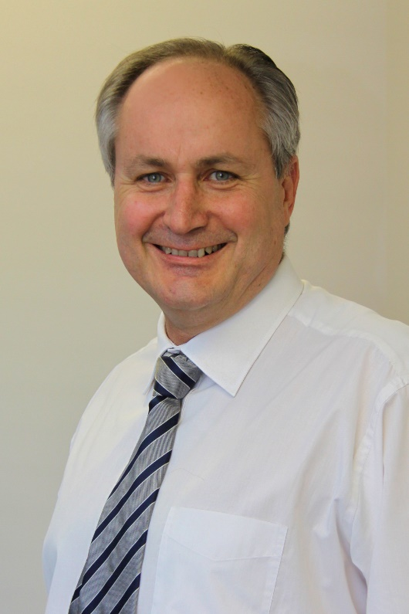
Dr. Purchase serves as a trustee of the Maize Trust, and in 2015 he was also appointed as Chairman of the Board of the South African Grain Information Services (SAGIS).
He serves on the Presidential Business Working Group of South Africa.
Among other awards, he received the 2011 Alumnus of the Year Award from the University of the Free State, as well as the 2012 South African Agriculturalist of the Year Award. In June 2013 he was elected to the Board of the International Food and Agribusiness Management Association (IFAMA).
For more details & registration visit www.cgasummit.co.za
Limited seats available.
Confirmed Speakers
- Mohammad Karaan (Dean of Faculty Agri Sciences, Stellenbosch University)
- Nico Groenewald (Standard Bank)
- Frans Cronjé (Institute of Race Relations)
- John Purchase (CEO, Agbiz)
- Mono Mashaba (Chairman, CGA-GDC)
- Jacomien De Klerk (General Manager, Citrus Academy)
- Thembeka Meyiwa (Intern, CGA)
- Julian Ribeiro (TBWA Hunt Lascaris)
- Jacques du Preez (Hortgro)
- Anton Kruger (CEO, FPEF)
- Hannes de Waal (CGA Lemon Focus Group)
- Jan-Louis Pretorius (CGA Grapefruit Focus Group)
- Graham Barry (Cultivar Specialist)
- Parth Karvat (Yupaa Group, India)
- Rocco Renaldi / Deon Joubert (CGA EU Representatives)
- Mikhail Fateev (CGA Russia Representative)
- Vaughan Hattingh (CEO, Citrus Research International)
- Inge Kotzé (World Wide Fund for Nature)
Costs (Registration fee):  CGA Members = R 1,200 + VAT  Exporters/Stakeholders = R 2,000 + VAT  Government Officials = R 1,200 + VAT  Students = R 1,200 + VAT  Overseas Delegates = $200  Optional Extras:  Gala Dinner (8th March) = R250pp + VAT  Study Tour (incl. accommodation) = R 1,500 + VAT  Summit Registration Includes:  - Welcome Dinner (7th March)  - Conference bag  - Tea, coffee and/or water  - Lunch (8th & 9th March)  - 1½ Day Conference | Programme:  Monday 6th March: Study Tour  Tuesday 7th March: Study Tour  Tuesday 7th March: Welcome Dinner for registered CGA Summit delegates  Wednesday 8th March: Day 1 of Summit  Wednesday 8th March: Gala Dinner  Thursday 9th March: Day 2 of Summit  Thursday 9th March: CGA Members Meeting scheduled for after Summit
Programme Download |  | Study Tour Programme Download

Copyright © 2016 Citrus Growers' Association, All rights reserved.
Sponsors:
