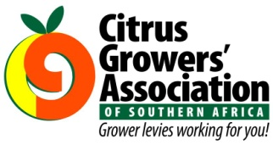 CGA GROUP
Grower Levies Working for You
in August 2013
 | The 2013 citrus export season has thrown up phytosanitary challenge after challenge. In August there were a number of cases that impacted growers’ ability to export citrus and I tried to help DAFF and producers to work through these issues where possible.  Paul Hardman – Industry Affairs Manager  ph@cga.co.za | 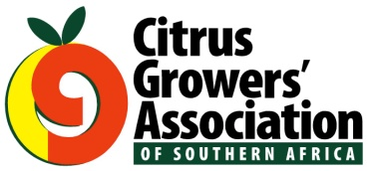
I joined CRI at the beginning of June this year. During August I visited Winterveldt to present a talk on Spring pests to emerging citrus farmers of the Winterveldt United Farmers Association. Experimental work has begun on aspects of FCM
and fruit fly control.
Dr Martin Gilbert - Research Entomologist
mg@cri.co.za
It is harvest season and I have innoculated fruit with green mould, treated fruit with different fungicides, rated infection symptoms, chopped and blended fruit for residue samples and
captured the data.
Bongiwe Ngcobo - Technical assistant - Post-harvest Plant Pathology and Diagnostic Clinic
Bongiwe@cri.co.za
 | We have monitored the progress of trials around the country, with promising results for 2 mandarins, (1 mid-season and 1 late), and several late to ultra-late Navels. At present we are planting out 16 new varieties that have come through Shoot Tip Grafting, (STG), into new trials with another 21 in the process of selection and STG.  Jon Roberts – General Manager  jon@cgacc.co.za | 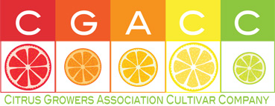
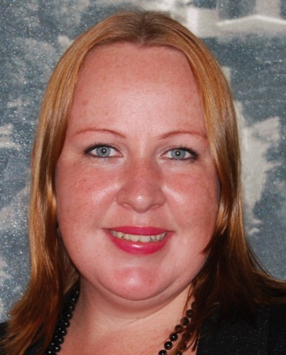 | This month I have been making arrangements for our Industry Exposure programme through which students will attend the IOCV Conference, Netafim Citrus Seminar, PMA Fresh Connections, CRI workshops, the Managing Quality Chains Conference in London and the 2013 Phyto-pathological Society in America.  Candice Burgin – Bursary Fund Administrator  Candice@citrusacademy.org.za

