BLYDE DAM, HOEDSPRUIT
10th January 2017.
Our dam is currently at 95%. I predicted that it will overflow before tomorrow evening without any more rain. This has changed! At 12h00 the flow below the potholes increased to 176 cumec. Highest was two days ago at 80 cumec. The flood wave was still upstream of the picnic spot. I guess the flood water is going to reach the dam within one hour and that the wall will overflow before tomorrow morning.
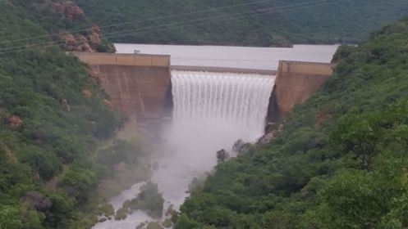

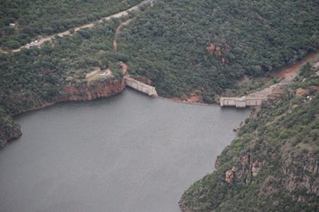
Taken on 10th January 2017.
Report from Amanda Pelser, Hoedspruit and forwarded to CGA by Alexan Coetzer

